**NAME: MOHAMMAD SHOAB**

**REG.NO: 20BCY10054**

**Campus: VIT Bhopal**

**Title: Linux Command List Assessment**

**Instructions:-**

The following assessment aims to test your understanding and practical knowledge of various Linux commands. Perform the tasks given below using the appropriate commands. Write down the command(s) used to complete each task. You can use any Linux distribution or command-line interface of your choice. Ensure that you provide the correct output or results for each task.

Note: It is recommended to perform this assessment on a Linux machine or virtual environment.

**File and Directory Operations:**

ls: List files and directories

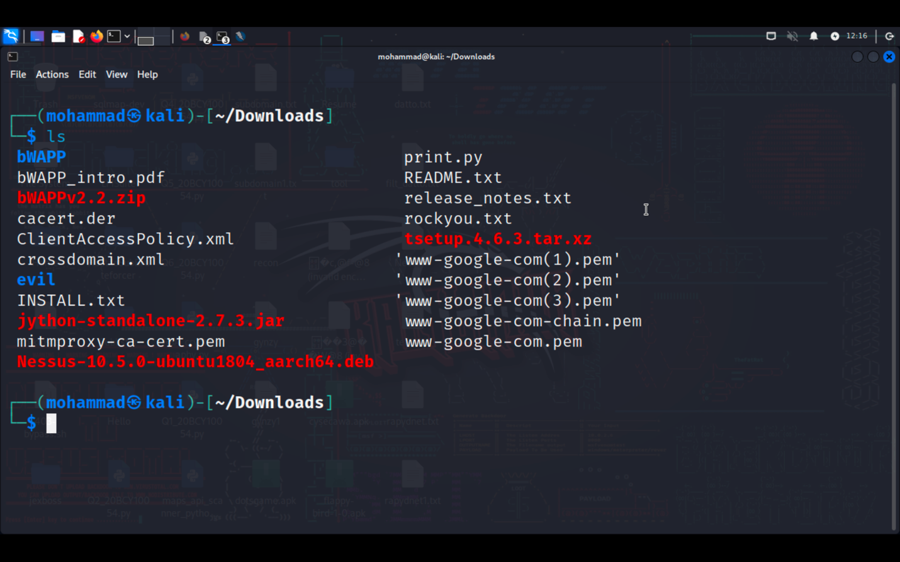

cd: Change directory

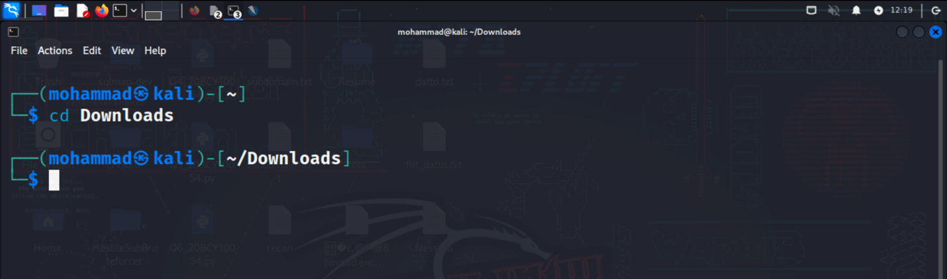

pwd: Print working directory

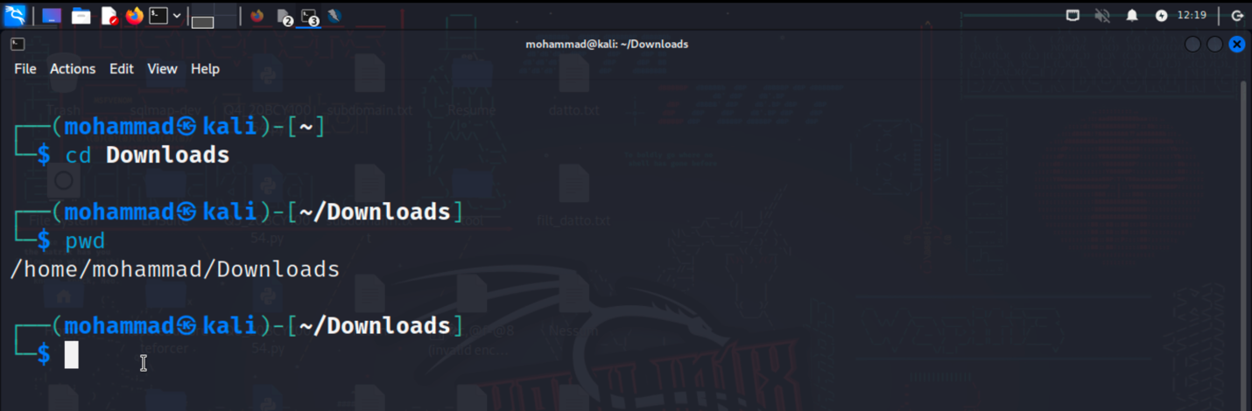

mkdir: Make directory

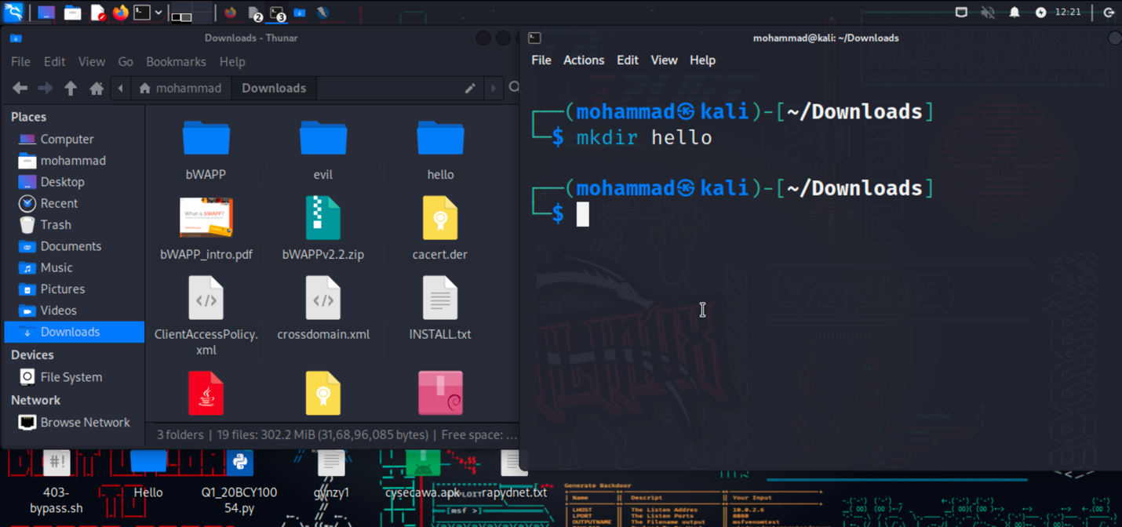

touch: Create an empty file

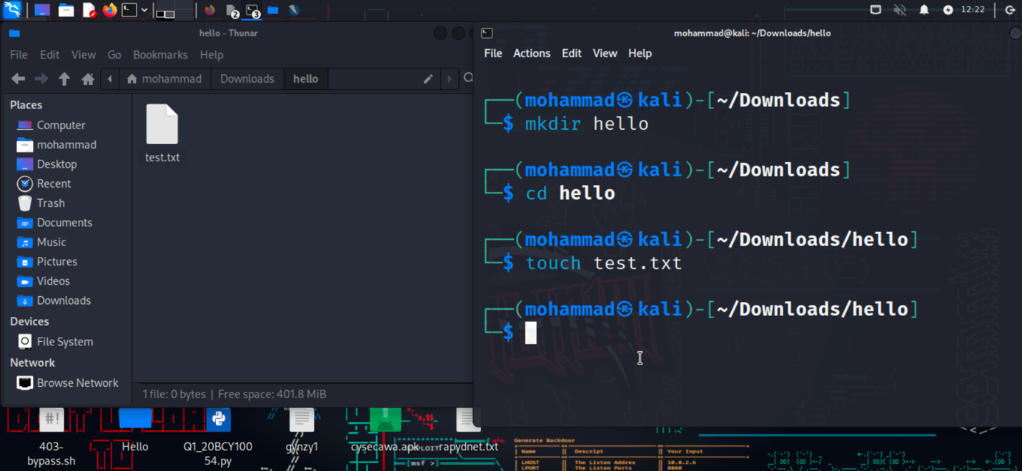

cp: Copy files and directories

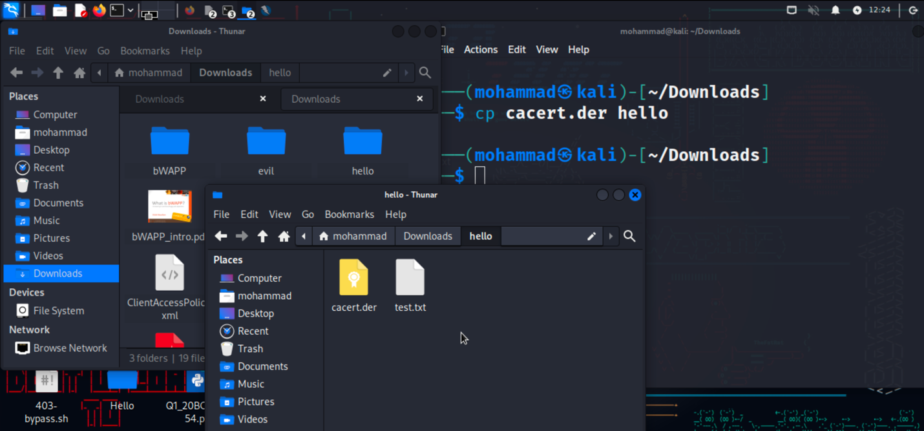

mv: Move or rename files and directories

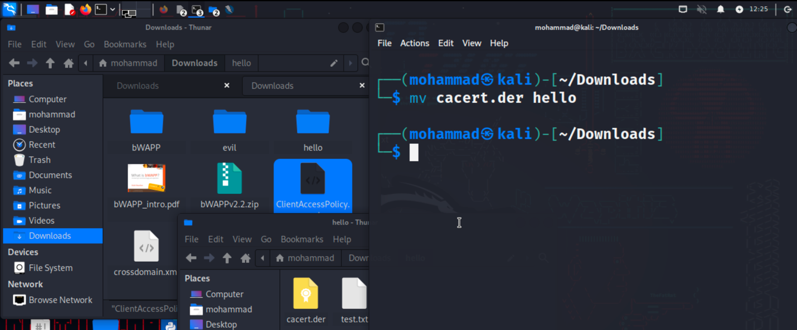

rm: Remove files and directories

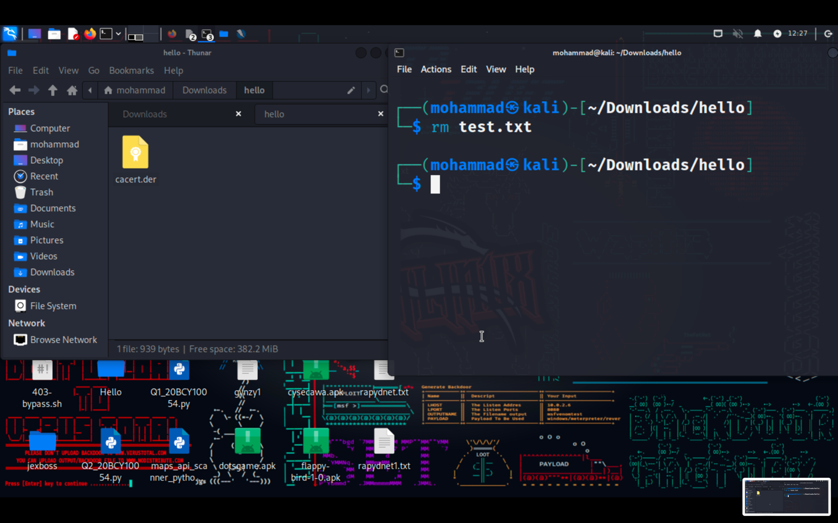

find: Search for files and directories

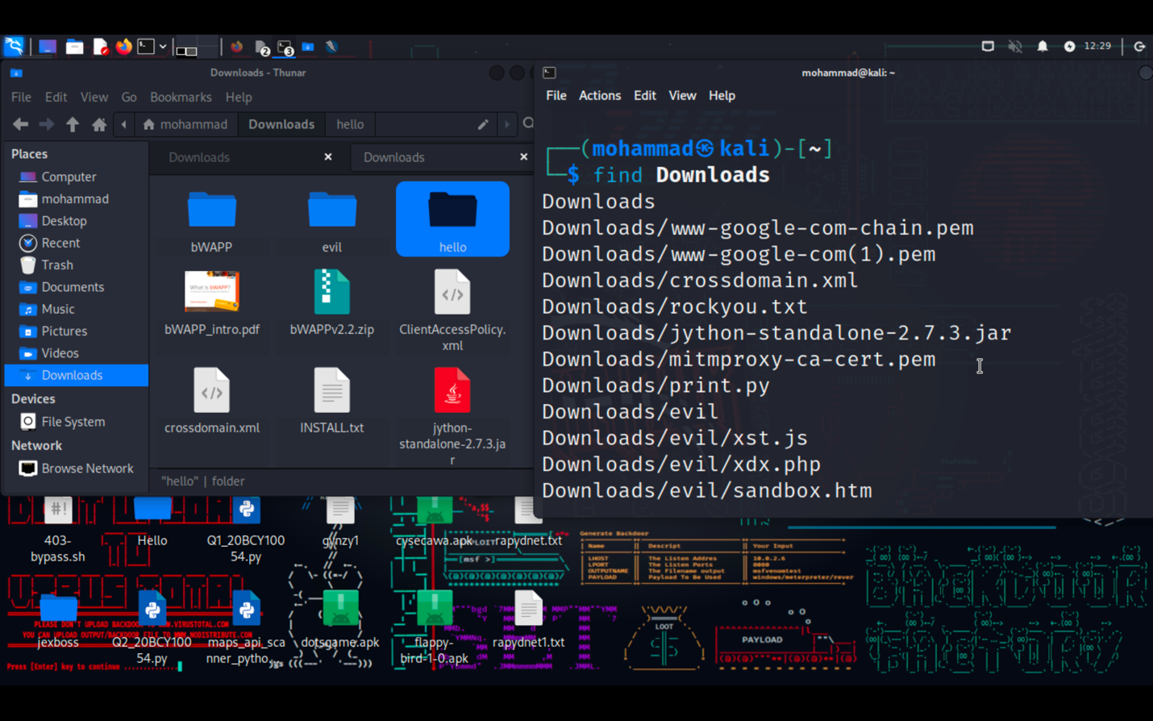

**File Viewing and Editing:**

cat: Concatenate and display file content

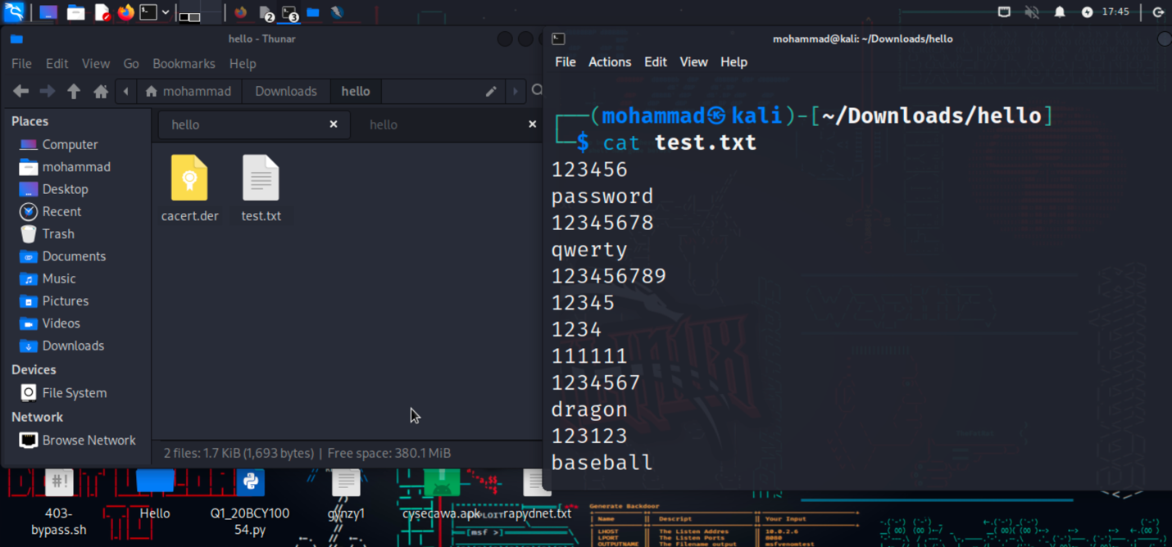

less: View file content with pagination

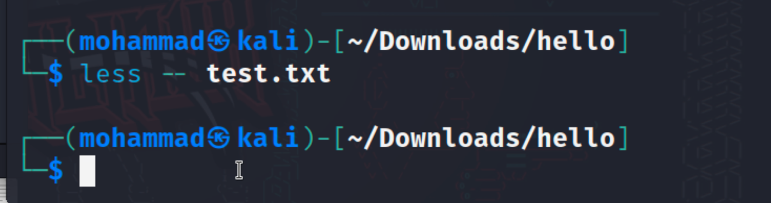

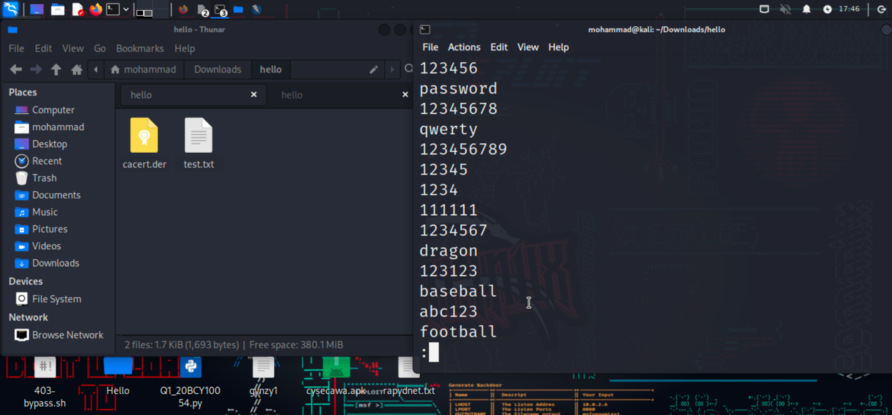

head: Display the beginning of a file

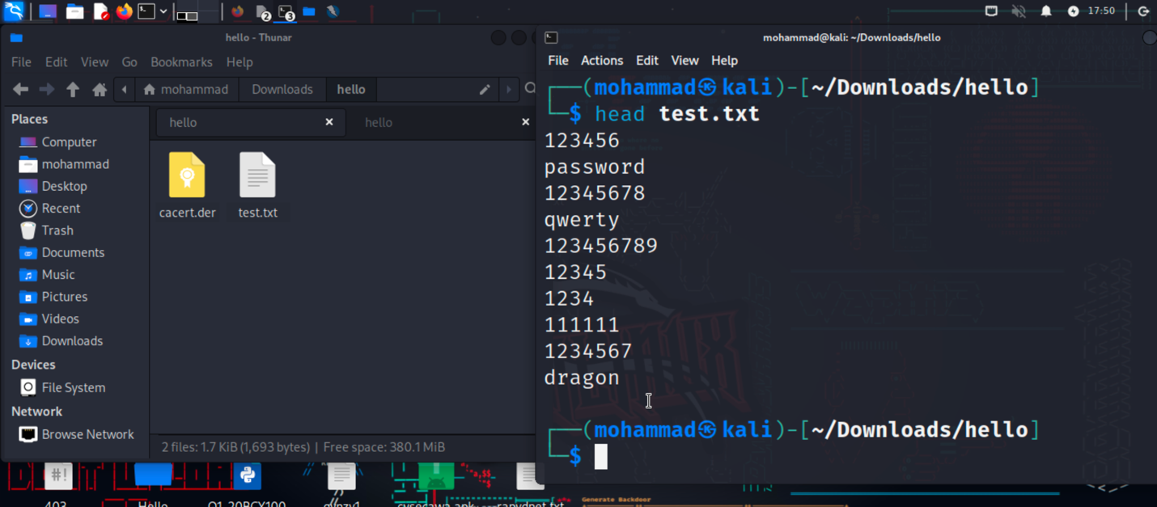

tail: Display the end of a file

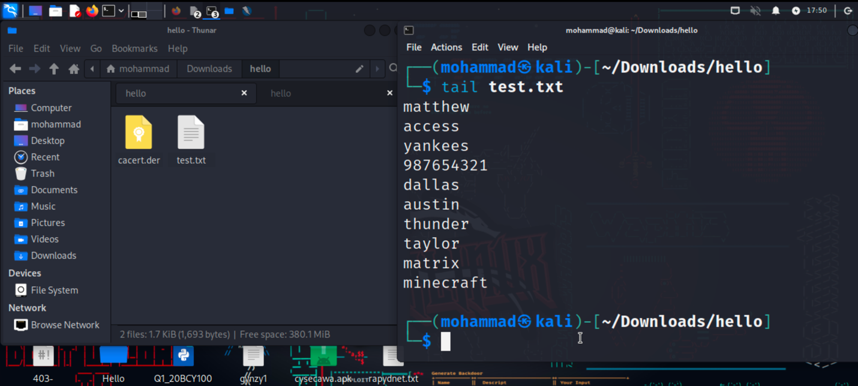

nano: Text editor for creating and editing files

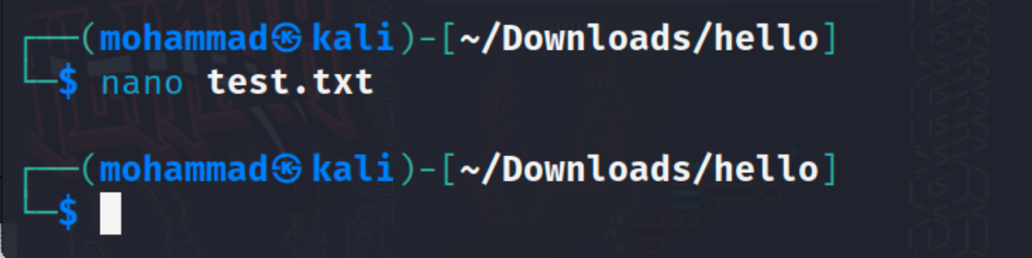

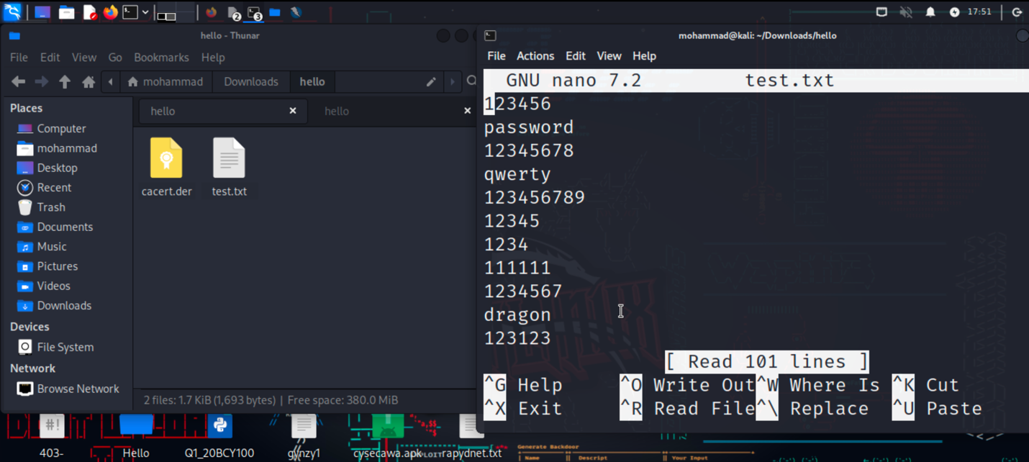

vi/vim: Powerful text editor for experienced users

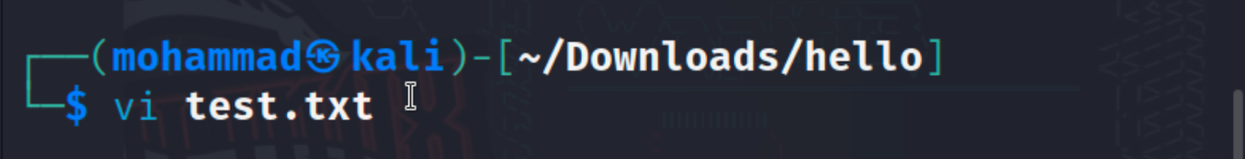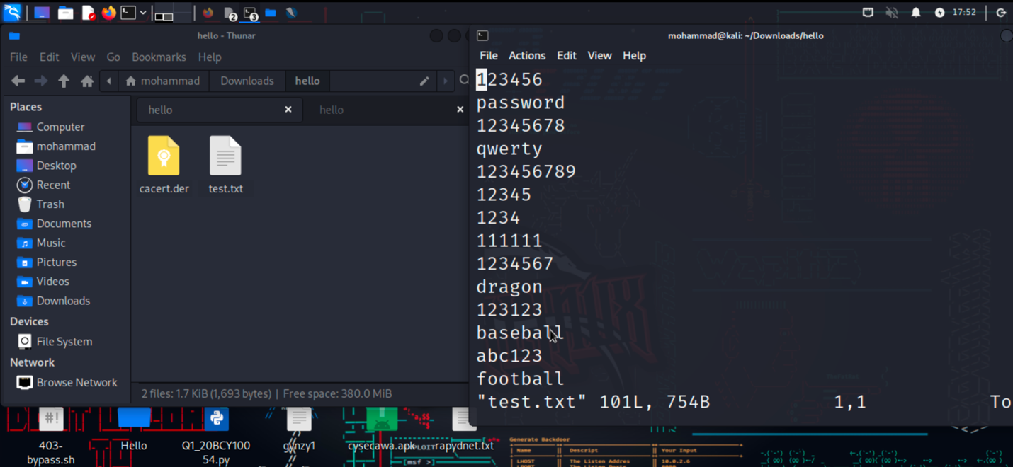

**File Permissions:**

chmod: Change file permissions

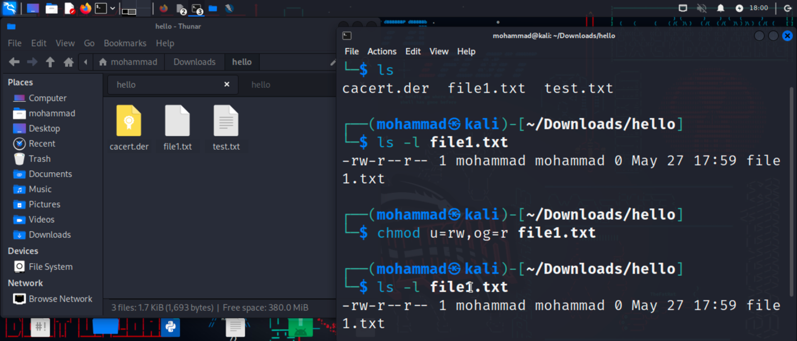

chown: Change file owner

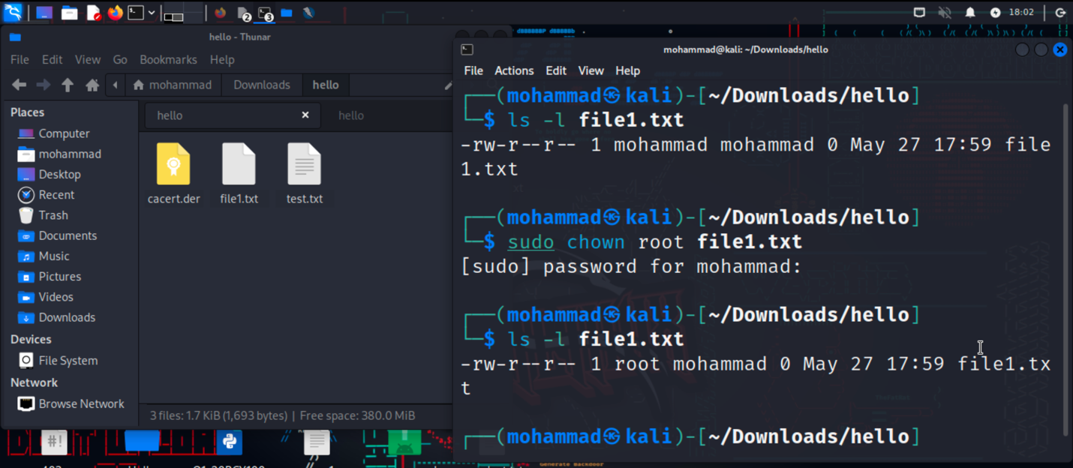

chgrp: Change file group

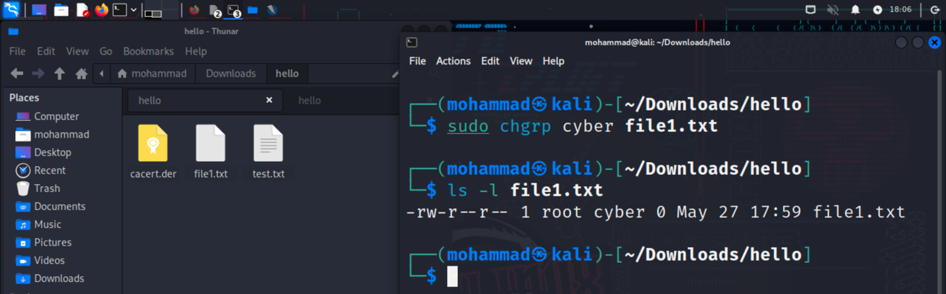

**File Compression and Archiving:**

tar: Archive files

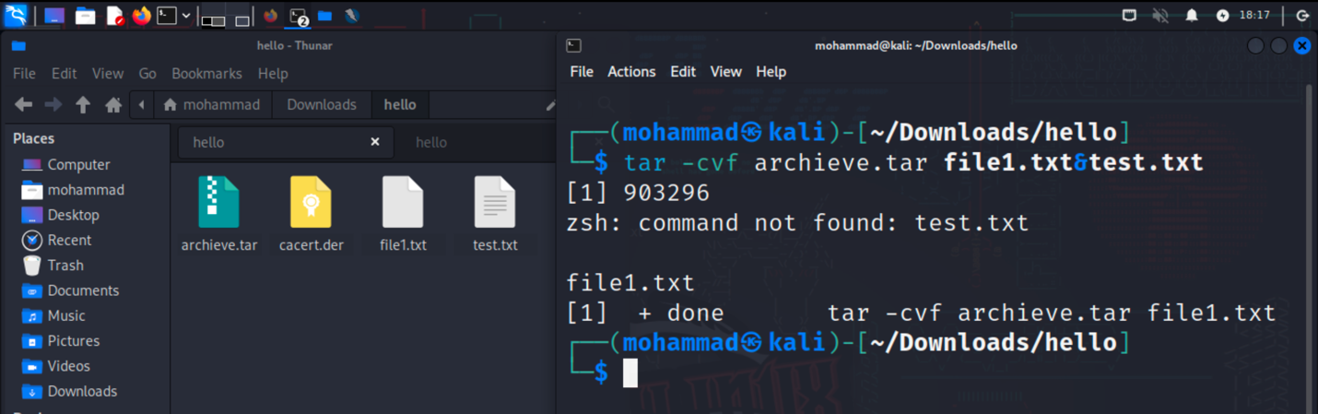

gzip: Compress files

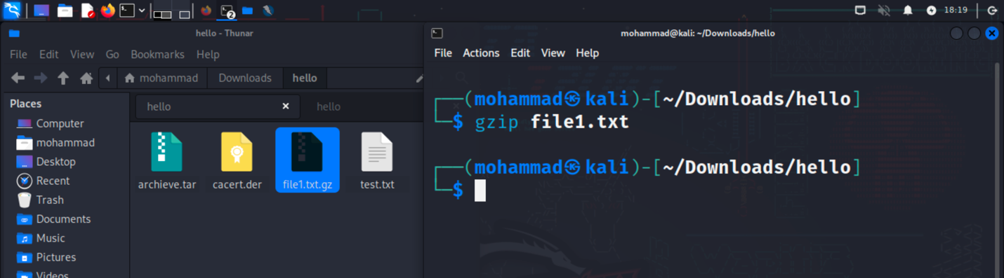

unzip: Extract files from a ZIP archive

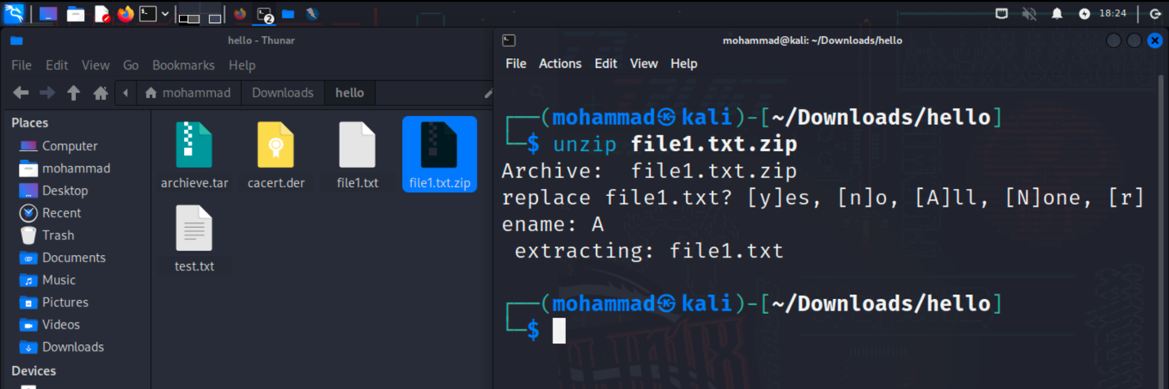

**Process Management:**

ps: List running processes

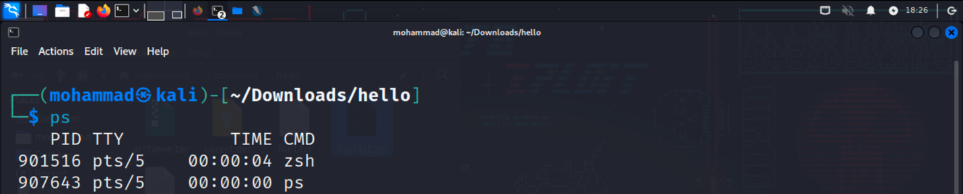

top: Display real-time system information and processes

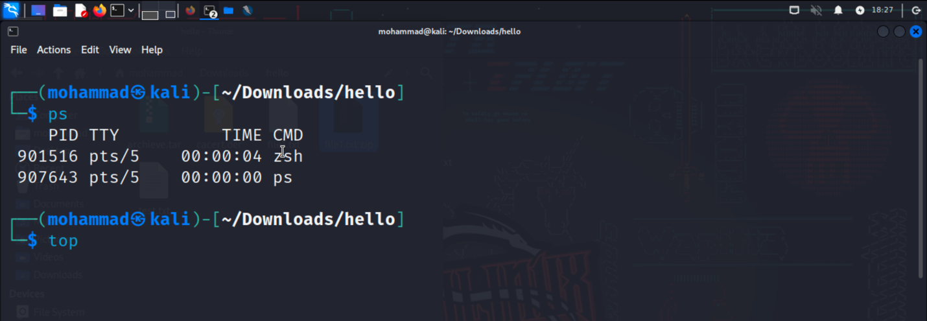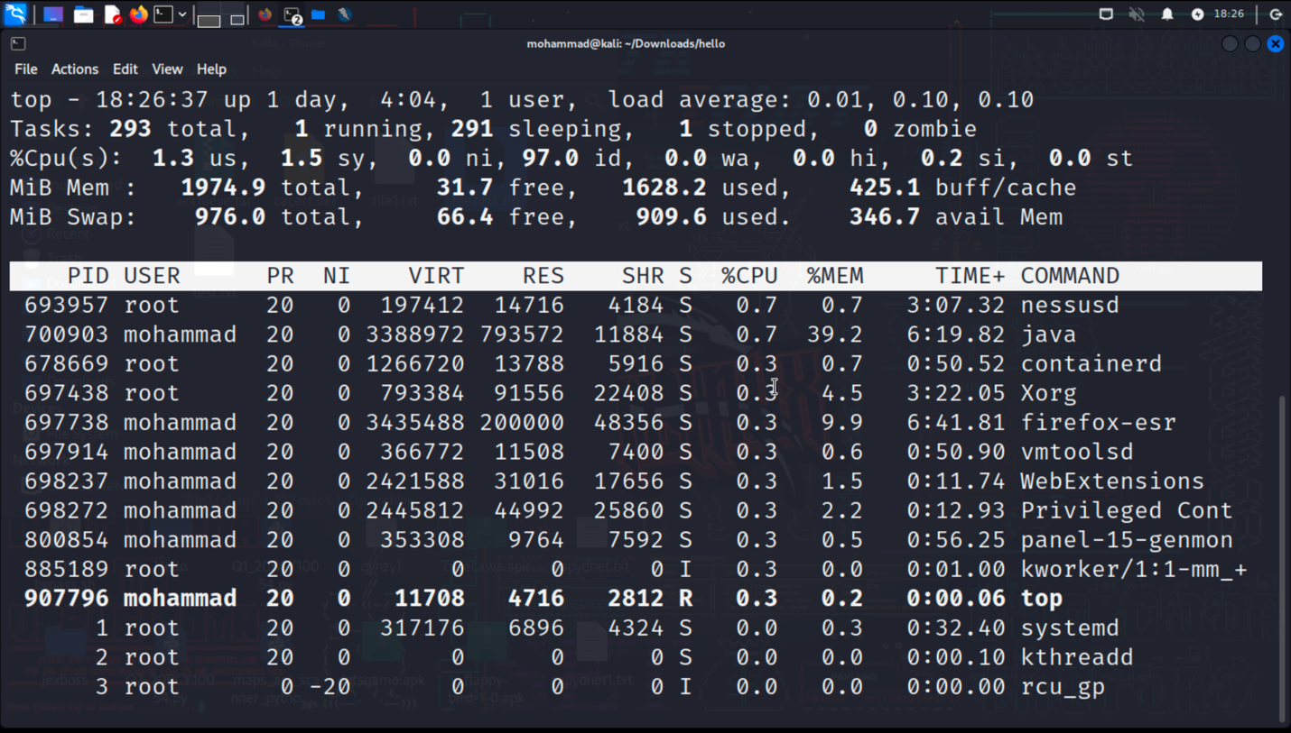

kill: Terminate processes

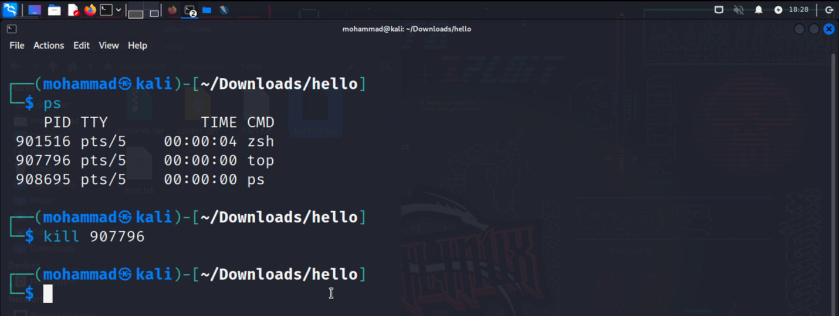

bg: Run processes in the background

fg: Bring background processes to the foreground

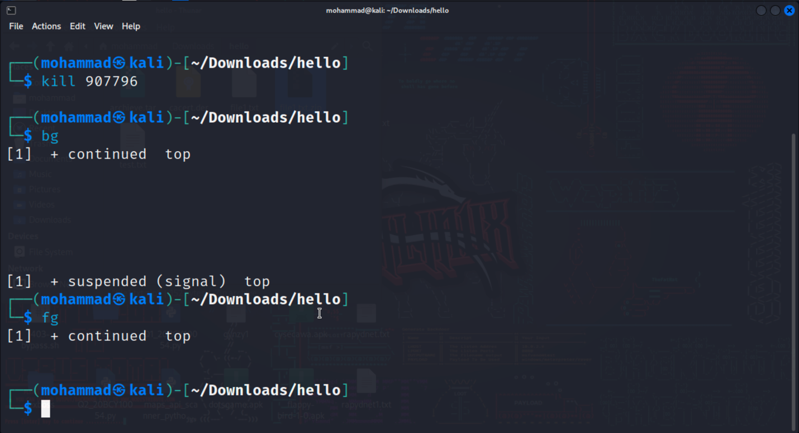

**System Information:**

uname: Print system information

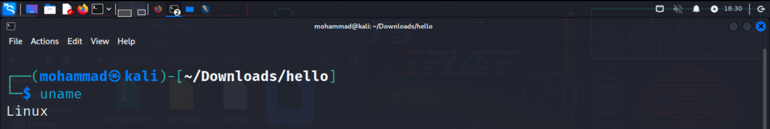

df: Display disk space usage

free: Display memory usage

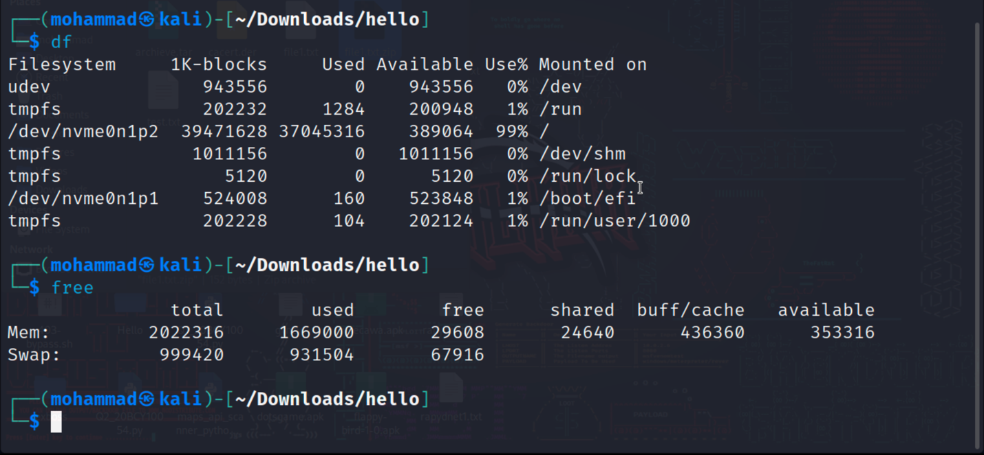

uptime: Show system uptime

who: Display logged-in users

w: Display logged-in users and their activities

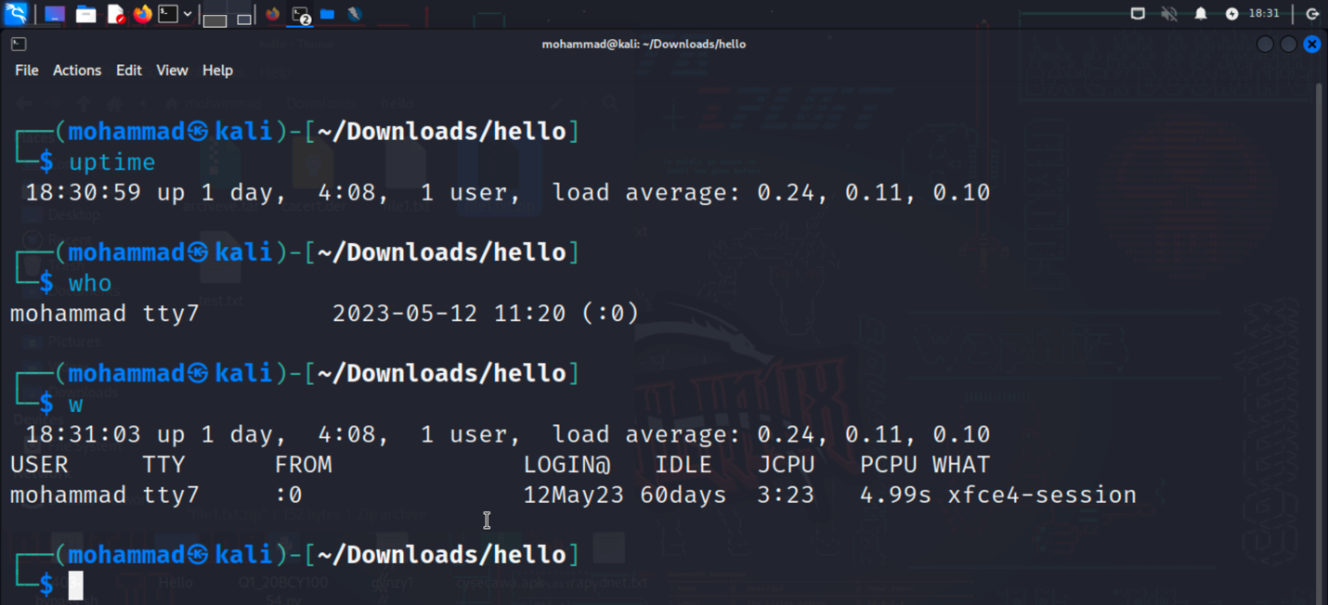

**Networking:**

ifconfig: Configure network interfaces

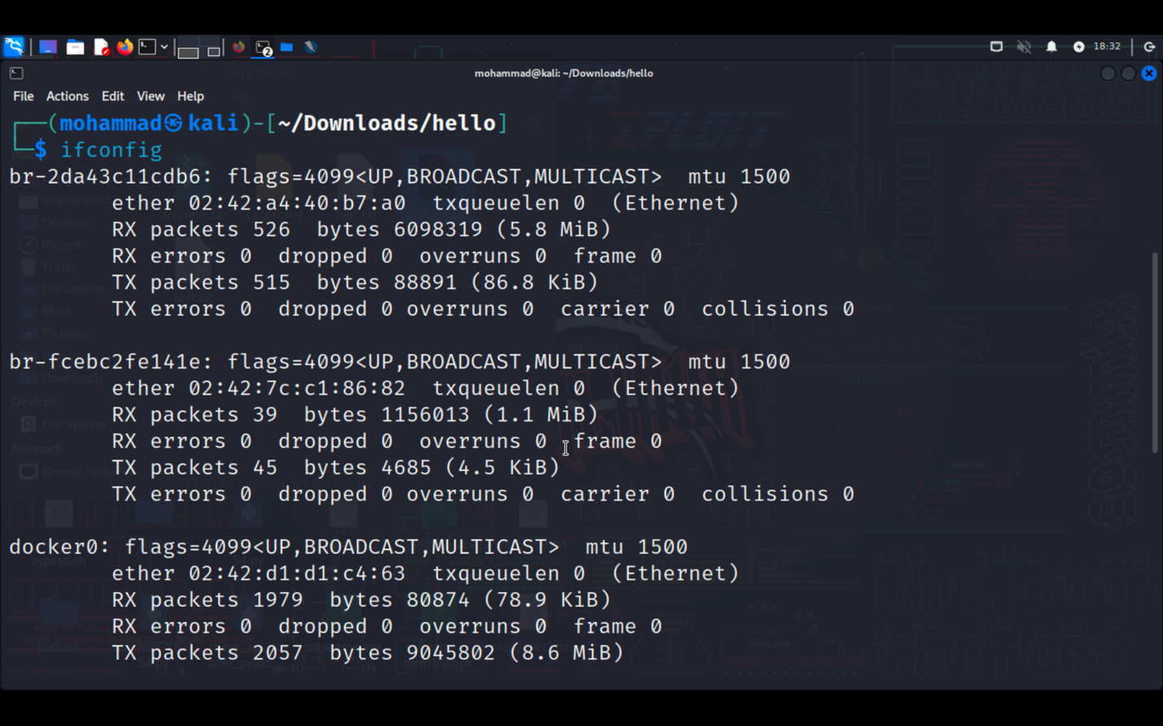

ping: Send ICMP echo requests to a network host

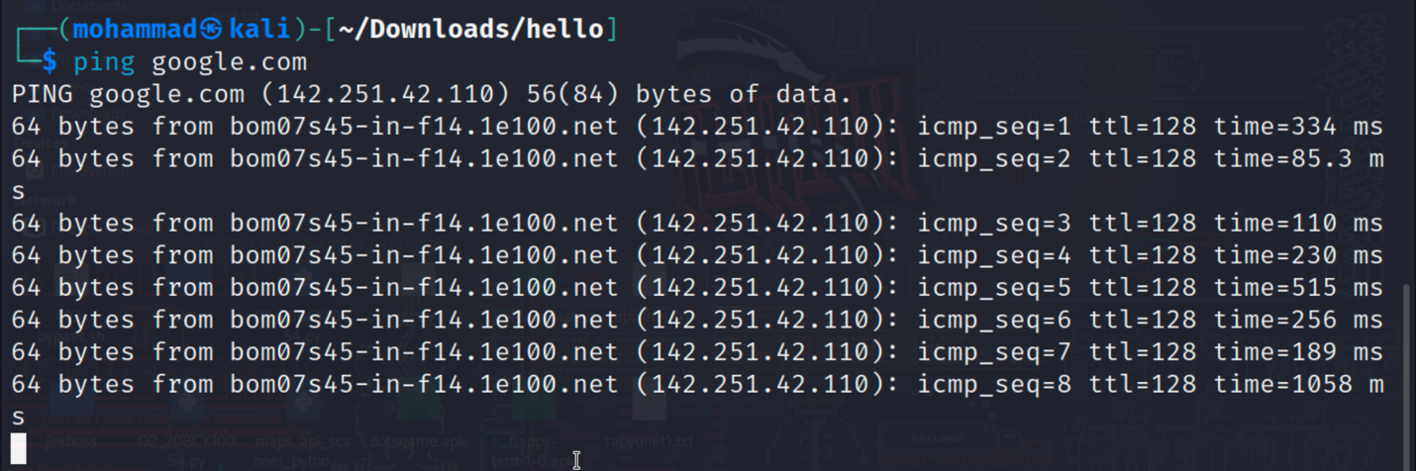

ssh: Securely connect to a remote system

scp: Securely copy files between systems

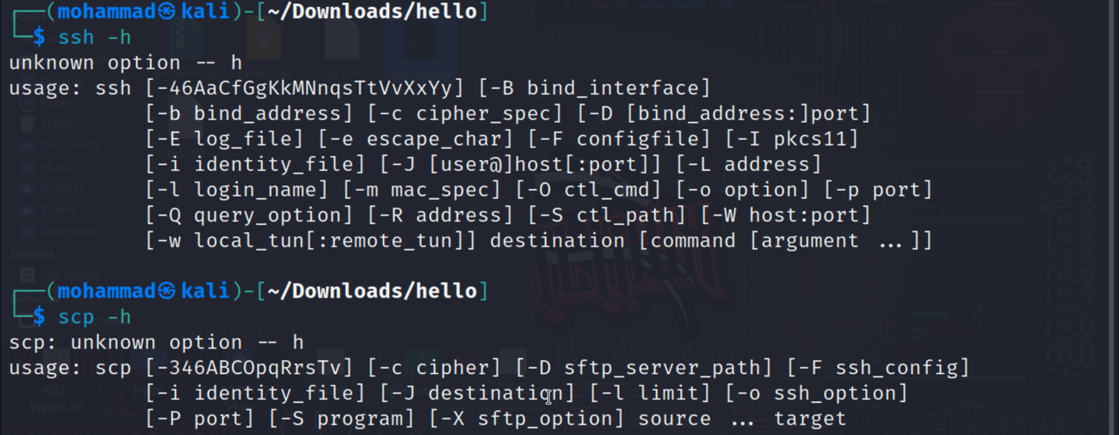

wget: Download files from the web

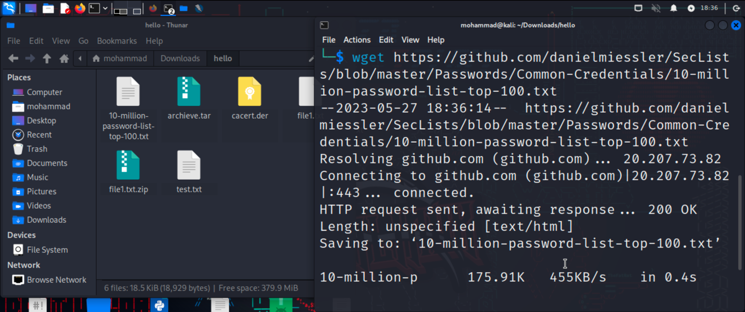

**System Administration:**

sudo: Execute commands with superuser privileges

apt-get: Package management for Debian-based distributions

yum: Package management for Red Hat-based distributions

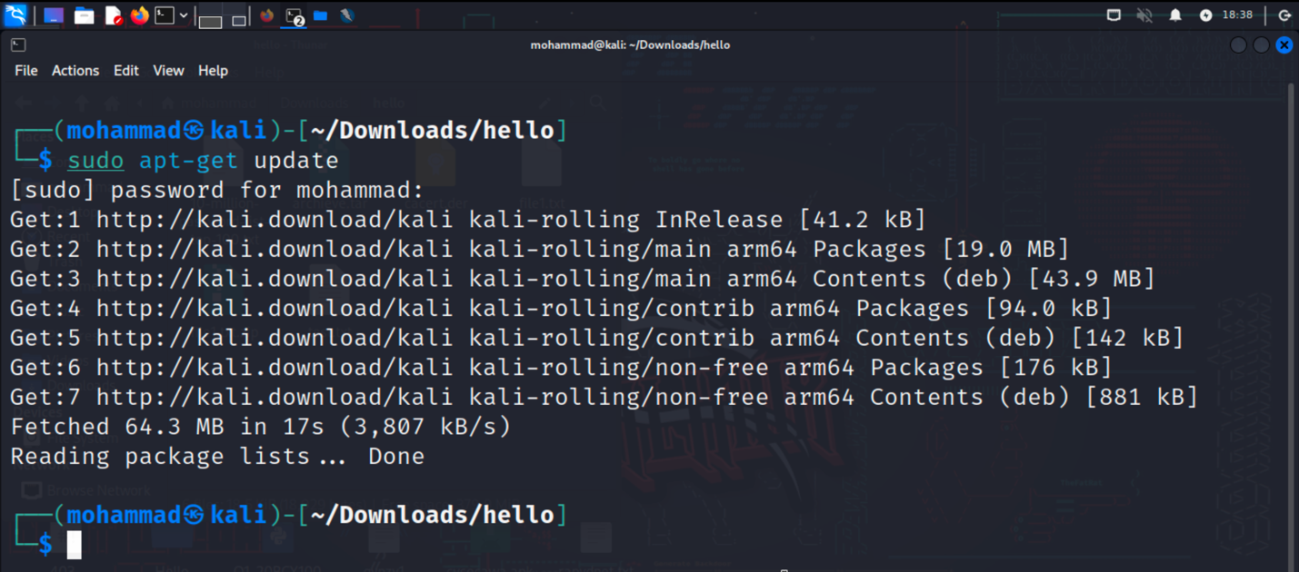

systemctl: Manage system services

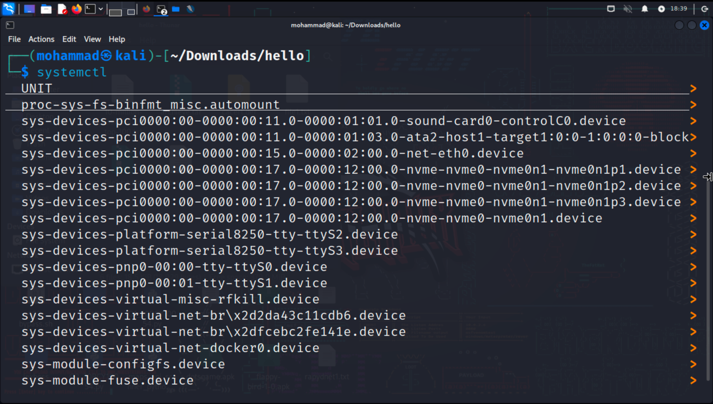

crontab: Schedule recurring tasks

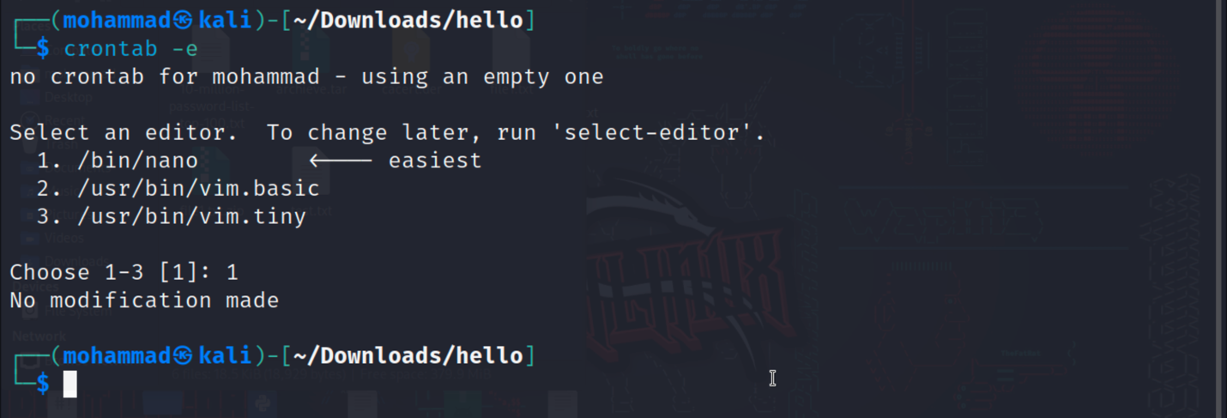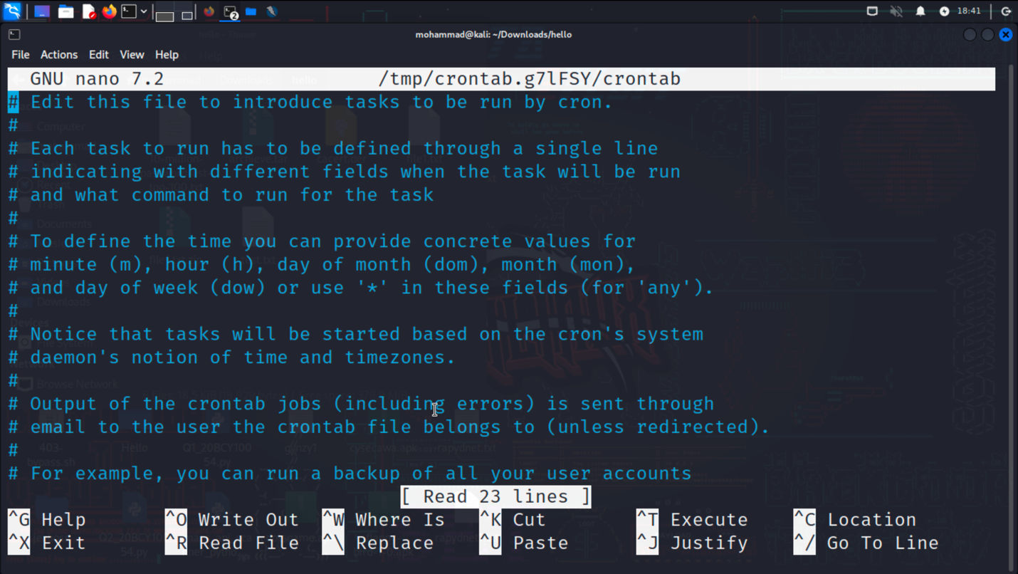

useradd: Add a new user

passwd: Change user password

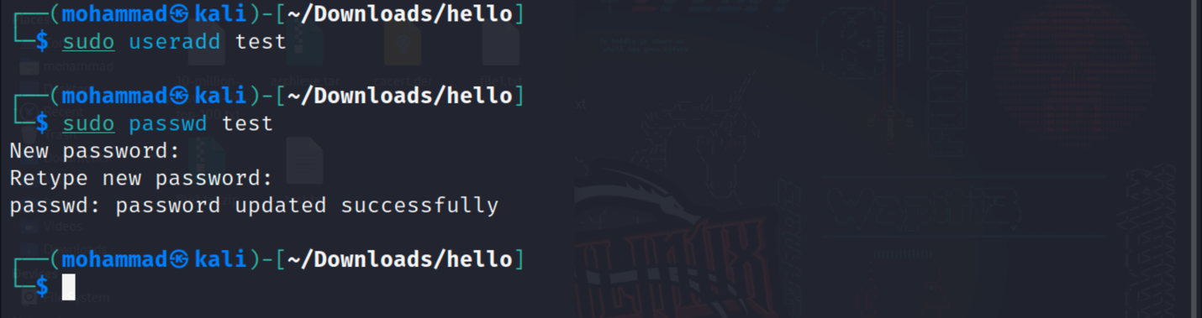

Ensure that you provide the correct command(s) used to accomplish each task. Write your answers below each task.

Once you have completed the assessment, review your answers and verify that the output or results are correct.

Make this in doucement format and send them with images